**09/10/2020 EXPERIMENT-10**

**AIM-** Basic 2D and 3D plots: parametric space curve, polygons with vertices, 3D contour lines, pie and bar charts.

**TOOLS USED –** MATLAB 7.0

**THEORY-** Parameterized curve:

A parameterized curve is a vector representation of a curve that lies in 2 or 3-dimensional space.

MATLAB PROGRAMS-

Syms t

xt=sin(t);

yt=cos(t);

zt=t;

fplot3(xt,yt,zt,[-4 5])

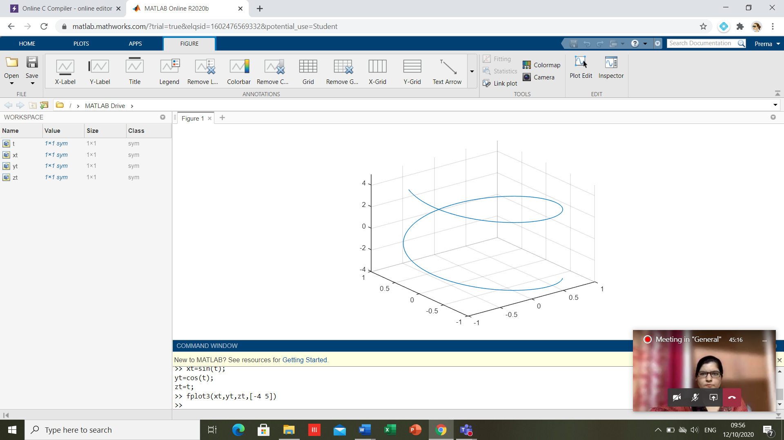

fplot3(xt,yt,zt,[-4 5])

p=polyshape([2 4 6 3 2.5],[4 5 3 1 3.5]);

plot(p);

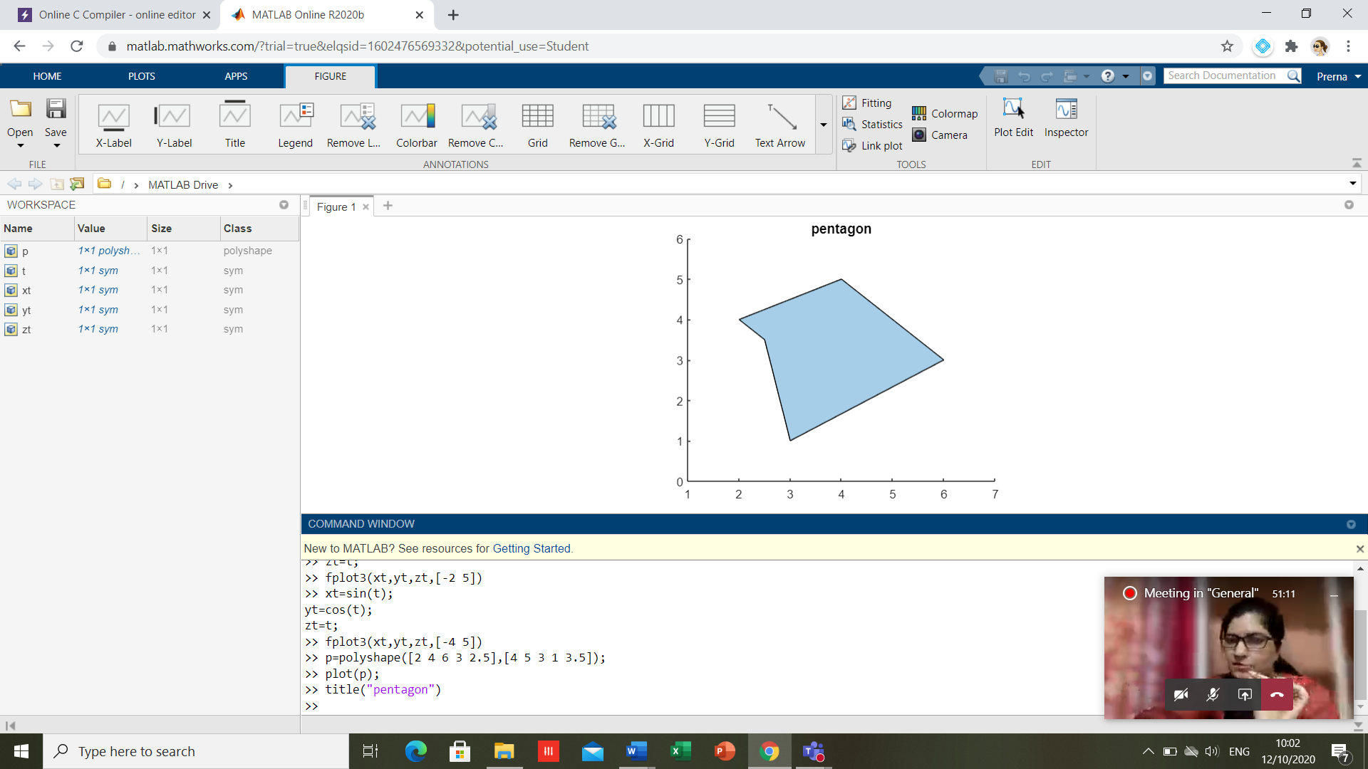

Q=[20 40 60 89 34 78]

Q =  
  
 20 40 60 89 34 78

pie(Q)

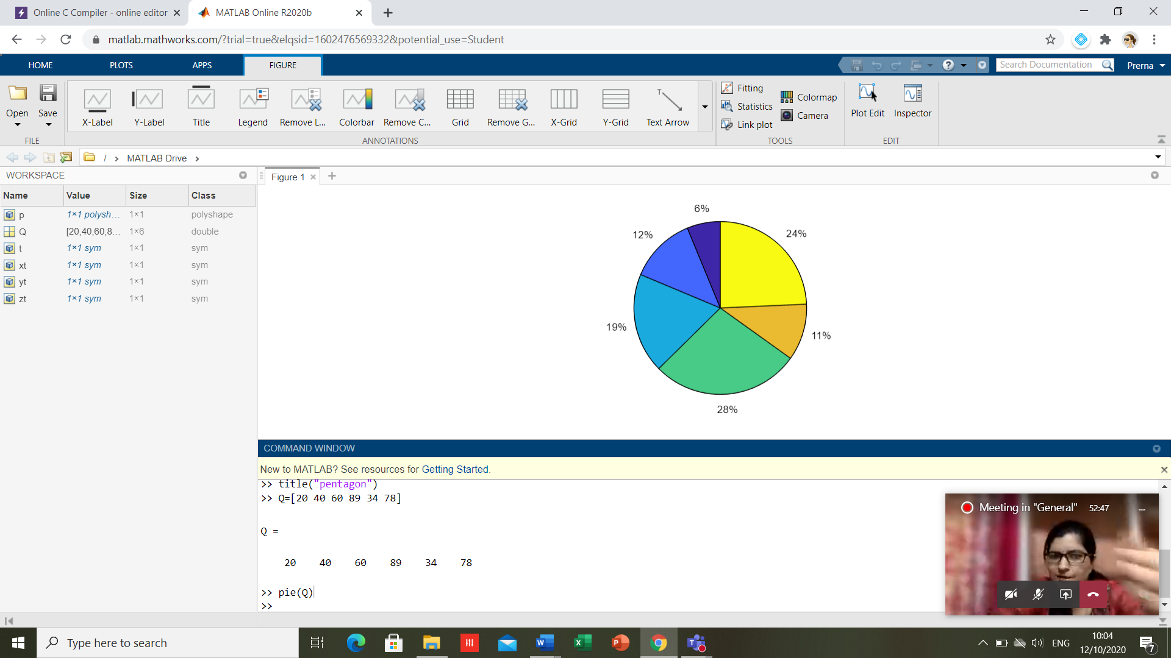

R=[454 178 2098]

R =  
  
 454 178 2098

bar(R)

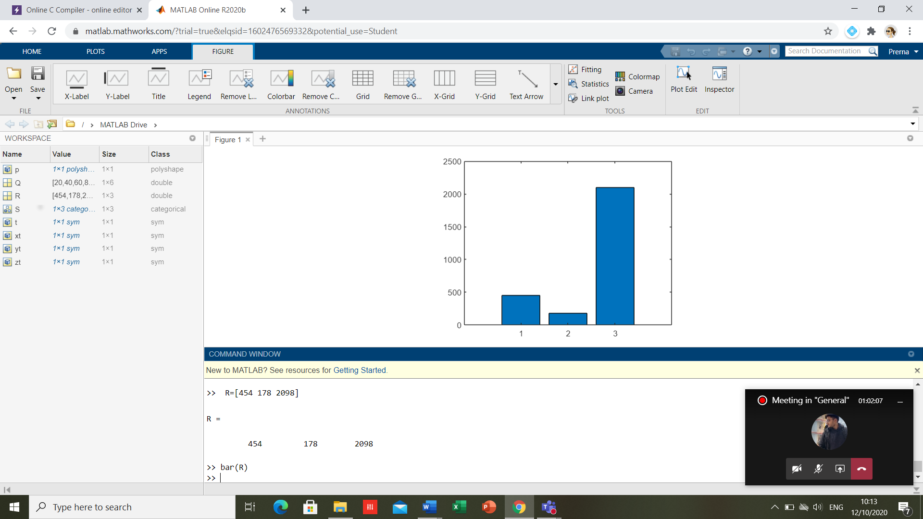

**CONCLUSION-** Basic 2D and 3D plots: parametric space curve, polygons with vertices, 3D contour lines, pie and bar charts has been plotted successfully.